## **SUBMISSION FLOW**

1. The candidates are supposed to have the **first** **submission for the project within the 10-day deadline**.
2. After the submission, candidates will receive feedback on their project, which they are supposed to **incorporate and re-submit** within 1 week of feedback.
3. All the candidates are supposed to get a total of **8 marks** to be prioritized in placements since it is necessary for Placements.
4. The **re-submissions** after **3 weeks** of launch in the batch will be de-prioritized during evaluations.
   1. Candidates will have to give the reason for their delay, to make sure that the team picks up their evaluation through mail or PI request.
   2. This will create backlogs as the project for the next module will also be released around the same time.
5. So make sure to submit the project (with the requirements) within the timeline.

## **GUIDELINES**

1. Ensure that the project is submitted within the 10-day deadline.
2. TA support won’t be answering any direct questions regarding the project.
3. Plagiarism will be checked during the evaluation.
4. Queries regarding submission should be asked to success champions.
5. Candidates must score >=8 out of 10 to be picked for referrals.
6. The ratings of level 9-10 will only be considered and included in the final feedback if someone is passing in all the Levels from 1 - 8. They (levels 1-8) are compulsory, in order to get passed in the final feedback.

## **COMPONENTS**

**All the components mentioned below hold significance while evaluation:**

1. **Excel File:**
   1. Data Cleaning
   2. Dashboarding
   3. Proper formatting
   4. The correct choice of visualization charts
2. **Doc File:**
   1. Exact answers to the objective questions
   2. Proper answers to the subjective questions with reasoning
   3. Proper formatting
3. **Presentation File:**
   1. Proper storytelling
   2. Proper formatting

## **EVALUATION**

* The projects will be evaluated on **10 levels (Each learner will receive detailed feedback)**.
* On each level, learners will get a **rating out of 5**, if the rating is smaller than 4, they won’t be considered as passed at that level.
* Learners have to get **>=4 (or passed)** in at least **8 levels** to get **>=8** as the final rating in the project.
* In the final feedback, only the final feedback out of 10 will be considered.

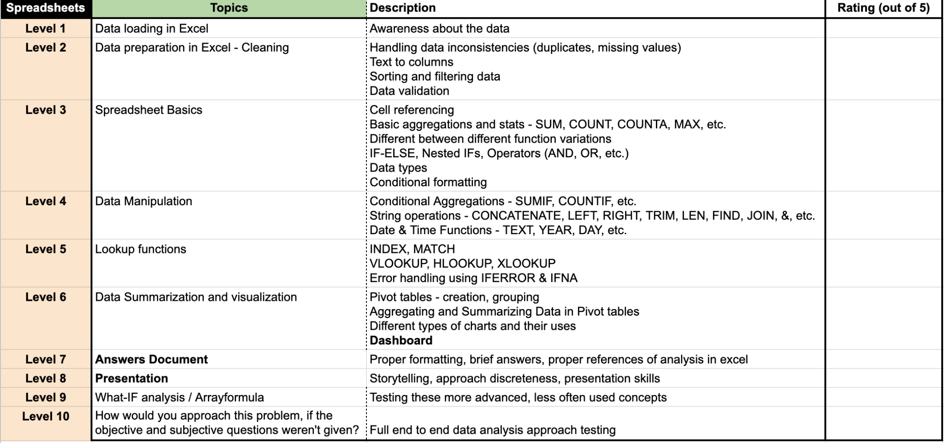

**Feedback Form**

* In the following feedback form, there is only one level (i.e. level 1) at which the candidate didn’t pass because he got rated <=4, that’s why he is given the feedback that his answer to Objective Question 1 is not correct.
* Due to this, only the candidate is rated 9 out of 10 in the final feedback.

**Note**: The following feedback form is just a sample it may differ across modules but the format remains the same.

